**23-01-2018**

**RESEARCH INFOTECH**

**DAILY ANALYSIS**

|  |
| --- |
| http://researchinfotech.co.in/storage/images/logo.pngImage result for SEBI |

|  |
| --- |
| **AUROBINDO PHARMA LTD (NSE-AUROPHARMA)** |

|  |  |  |
| --- | --- | --- |
| **BUY** | **639-640** | **SL-618** |
| **TGT 1- 660** | **TGT 2- 685** | **SL-618** |

|  |  |  |  |  |
| --- | --- | --- | --- | --- |
| **S2** | **S1** | **PP** | **R1** | **R2** |
| **525** | **598** | **640** | **675** | **750** |

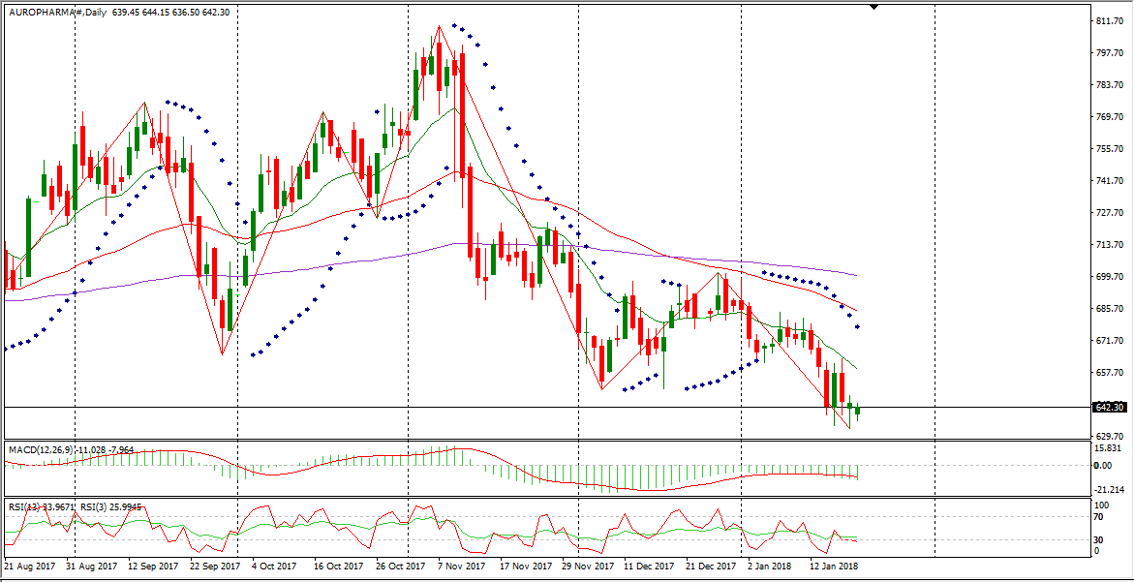

**DESCRIPTION**

Aurobindo Pharma Limited is a pharmaceutical company. The Company is engaged in producing oral and injectable generic formulations and active pharmaceutical ingredients (APIs). Its product portfolio is spread over seven therapeutic/product areas, including antibiotics, anti-retrovirals, cardiovascular, central nervous system, gastroenterologicals, anti-allergies and anti-diabetics. It is engaged in developing a range of oncology and hormonal products. It is also developing inhalation and dermatology products, such as pressurized metered-dose inhaler (pMDI). It markets its products through chain stores in the United States. It has developed over three injectable penem products. The Company, through its subsidiary, manufactures and sells nutritional supplements. It has over 10 manufacturing units and approximately two research and development centers. The Company, in addition to marketing its products domestically, also markets its products globally in over 150 countries.

|  |
| --- |
| http://researchinfotech.co.in/storage/images/logo.pngImage result for SEBI |

**TECHNICAL VIEW**

* In daily candle AUROPHARMA was looking strong, it was taking support of its 55 day’s EMA and looking bullish.
* From the opening it was falling down but in 15 minute candle stick, it took support of its short term moving average and I saw fresh buying near closing.
* Near closing I saw huge OI in AUROPHARMA.
* In daily candle it was taking support of its day’s low also and looking reversal, next trading it can be gap up opening.

**RECENT NEWS**

* Aurobindo Pharma Limited (AUROPHARMA.NS) Limping -2.61% For the Week
* Shares of Aurobindo Pharma Limited (AUROPHARMA.NS) have been trending lower over the past five bars, revealing bearish momentum for the shares, as they ran -2.61% for the week. Looking further out we note that the shares have moved -6.28% over the past 4-weeks, -14.62% over the past half year and -8.70% over the past full year.
* Aurobindo Pharma Limited (AUROPHARMA.NS) currently has a 14 day Williams %R of -84.71. In general, if the level goes above -20, the stock may be considered to be overbought. Alternately, if the indicator goes under -80, this may signal that the stock is oversold. The Williams Percent Range or Williams %R is a technical indicator that was developed to measure overbought and oversold market conditions. The Williams %R indicator helps show the relative situation of the current price close to the period being observed.
* Currently, the 200-day MA for Aurobindo Pharma Limited (AUROPHARMA.NS) is sitting at 685.38. The Relative Strength Index (RSI) is a momentum oscillator that measures the speed and change of stock price movements. The RSI was developed by J. Welles Wilder, and it oscillates between 0 and 100. Generally, the RSI is considered to be oversold when it falls below 30 and overbought when it heads above 70. RSI can be used to detect general trends as well as finding divergences and failure swings. The 14-day RSI is presently standing at 35.14, the 7-day is 30.34, and the 3-day is resting at 25.72.

## **DISCLOSURE**

RESEARCH INFOTECH DO NOT RECEIVE ANY CONSIDERATION BY WAY OF REMUNERATION OR COMPENSATION OR IN ANY OTHER FORM WHATSOEVER, BY US OR ANY OF OUR ASSOCIATES OR SUBSIDIARIES FOR ANY DISTRIBUTION OR EXECUTION SERVICES IN RESPECT OF THE PRODUCTS OR SECURITIES FOR WHICH THE INVESTMENT ADVICE IS PROVIDED TO THE CLIENT.

RESEARCH INFOTECH DO NOT RECOMMEND A STOCK/COMMODITY BROKER. IF ANY STOCK/COMMODITY BROKER IS RECOMMENDED BY ANY OF OUR REPRESENTATIVE, WE DO NOT RECEIVE ANY CONSIDERATION BY WAY OF REMUNERATION OR COMPENSATION OR IN ANY OTHER FORM WHATSOEVER FROM STOCK/COMMODITY BROKER OR ANY OTHER INTERMEDIARY SO RECOMMENDED TO CLIENT.

TO ENSURE COMPLIANCE WITH THE INVESTMENT ADVISOR REGULATIONS 2013, WE HAVE RESOLVED THAT THE INVESTMENT ADVISOR AND ALL ITS REPRESENTATIVES WILL NOT MAKE ANY TRADES IN THE MARKET. WE ARE NOT ASSOCIATED IN ANY MANNER WITH ANY ISSUER OF PRODUCTS/ SECURITIES, THIS ENSURES THAT THERE IS NO ACTUAL OR POTENTIAL CONFLICTS OF INTEREST. THIS ALSO ENSURES THAT OBJECTIVITY OR INDEPENDENCE IN THE CARRYING ON OF INVESTMENT ADVISORY SERVICES IS NOT COMPROMISED. INVESTMENT IN STOCK/COMMODITY MARKETS IS SUBJECT TO MARKET RISK, THOUGH BEST ATTEMPTS ARE MADE FOR PREDICTING MARKETS, BUT NO SURETY OF RETURN OR ACCURACY OF ANY KIND IS GUARANTEED, WHILE THE PERFORMANCE SHEET OF VARIOUS PRODUCTS IS AVAILABLE BUT SHOULD NOT BE CONSIDERED AS A GUARANTEE FOR FUTURE PERFORMANCE OF THE PRODUCTS/SERVICES. CLIENTS ARE ADVISED TO CONSIDER ALL THE ADVICE AS JUST AN OPINION AND MAKE INVESTMENT DECISION ON THEIR OWN.

IN CASE OF CLIENTS SEEKING ADVICE ON ANY SPECIFIC POSITIONS ALREADY MADE BY THE CLIENT, WE WILL BE ABLE TO SUGGEST BEST POSSIBLE ACTION CONSIDERING OUR VIEW ON THE SECURITY OR PRODUCT. SUCH SUGGESTION UNDER ANY CIRCUMSTANCES SHALL BE CONSIDERED AS AN OPINION (NOT ADVICE) FROM OUR ORGANIZATION AND WE ADVISE CLIENT TO CONSIDER OUR OPINION AND NOT CONSULTANCY TO MAKE HIS/HER FINAL DECISION. WE ARE NOT LIABLE FOR ANY LOSSES WHATSOEVER CLIENT MAY INCUR IN ACCEPTING THIS OPINION.

CLIENT IS ALSO ADVISED TO TRADE ONLY IF TIPS SUIT HIS CURRENT RISK APPETITE AND RISK BEARING CAPACITY, ALL SUCH TIPS SHALL BE CONSIDERED AS A VIEW OR OPINION AND CLIENT SHALL ON HIS/HER DISCRETION DECIDE ACTUAL TRADES.

WE ARE NOT ASSOCIATED WITH ANY INTERMEDIARIES AND DO NOT RECOMMEND SERVICES OF ANY SPECIFIC INTERMEDIARIES.  
NO LITIGATIONS HAVE BEEN FILED AGAINST US SINCE THE INCORPORATION.

ALL THE TIPS WHICH ARE SUGGESTED BY US ARE COMMUNICATED IN WRITTEN, NO VERBAL COMMUNICATION FROM ANY OF THE EXECUTIVES OR OTHERWISE UNDER ANY CIRCUMSTANCES SHALL BE CONSIDERED AS ADVICE BY OUR ORGANIZATION.